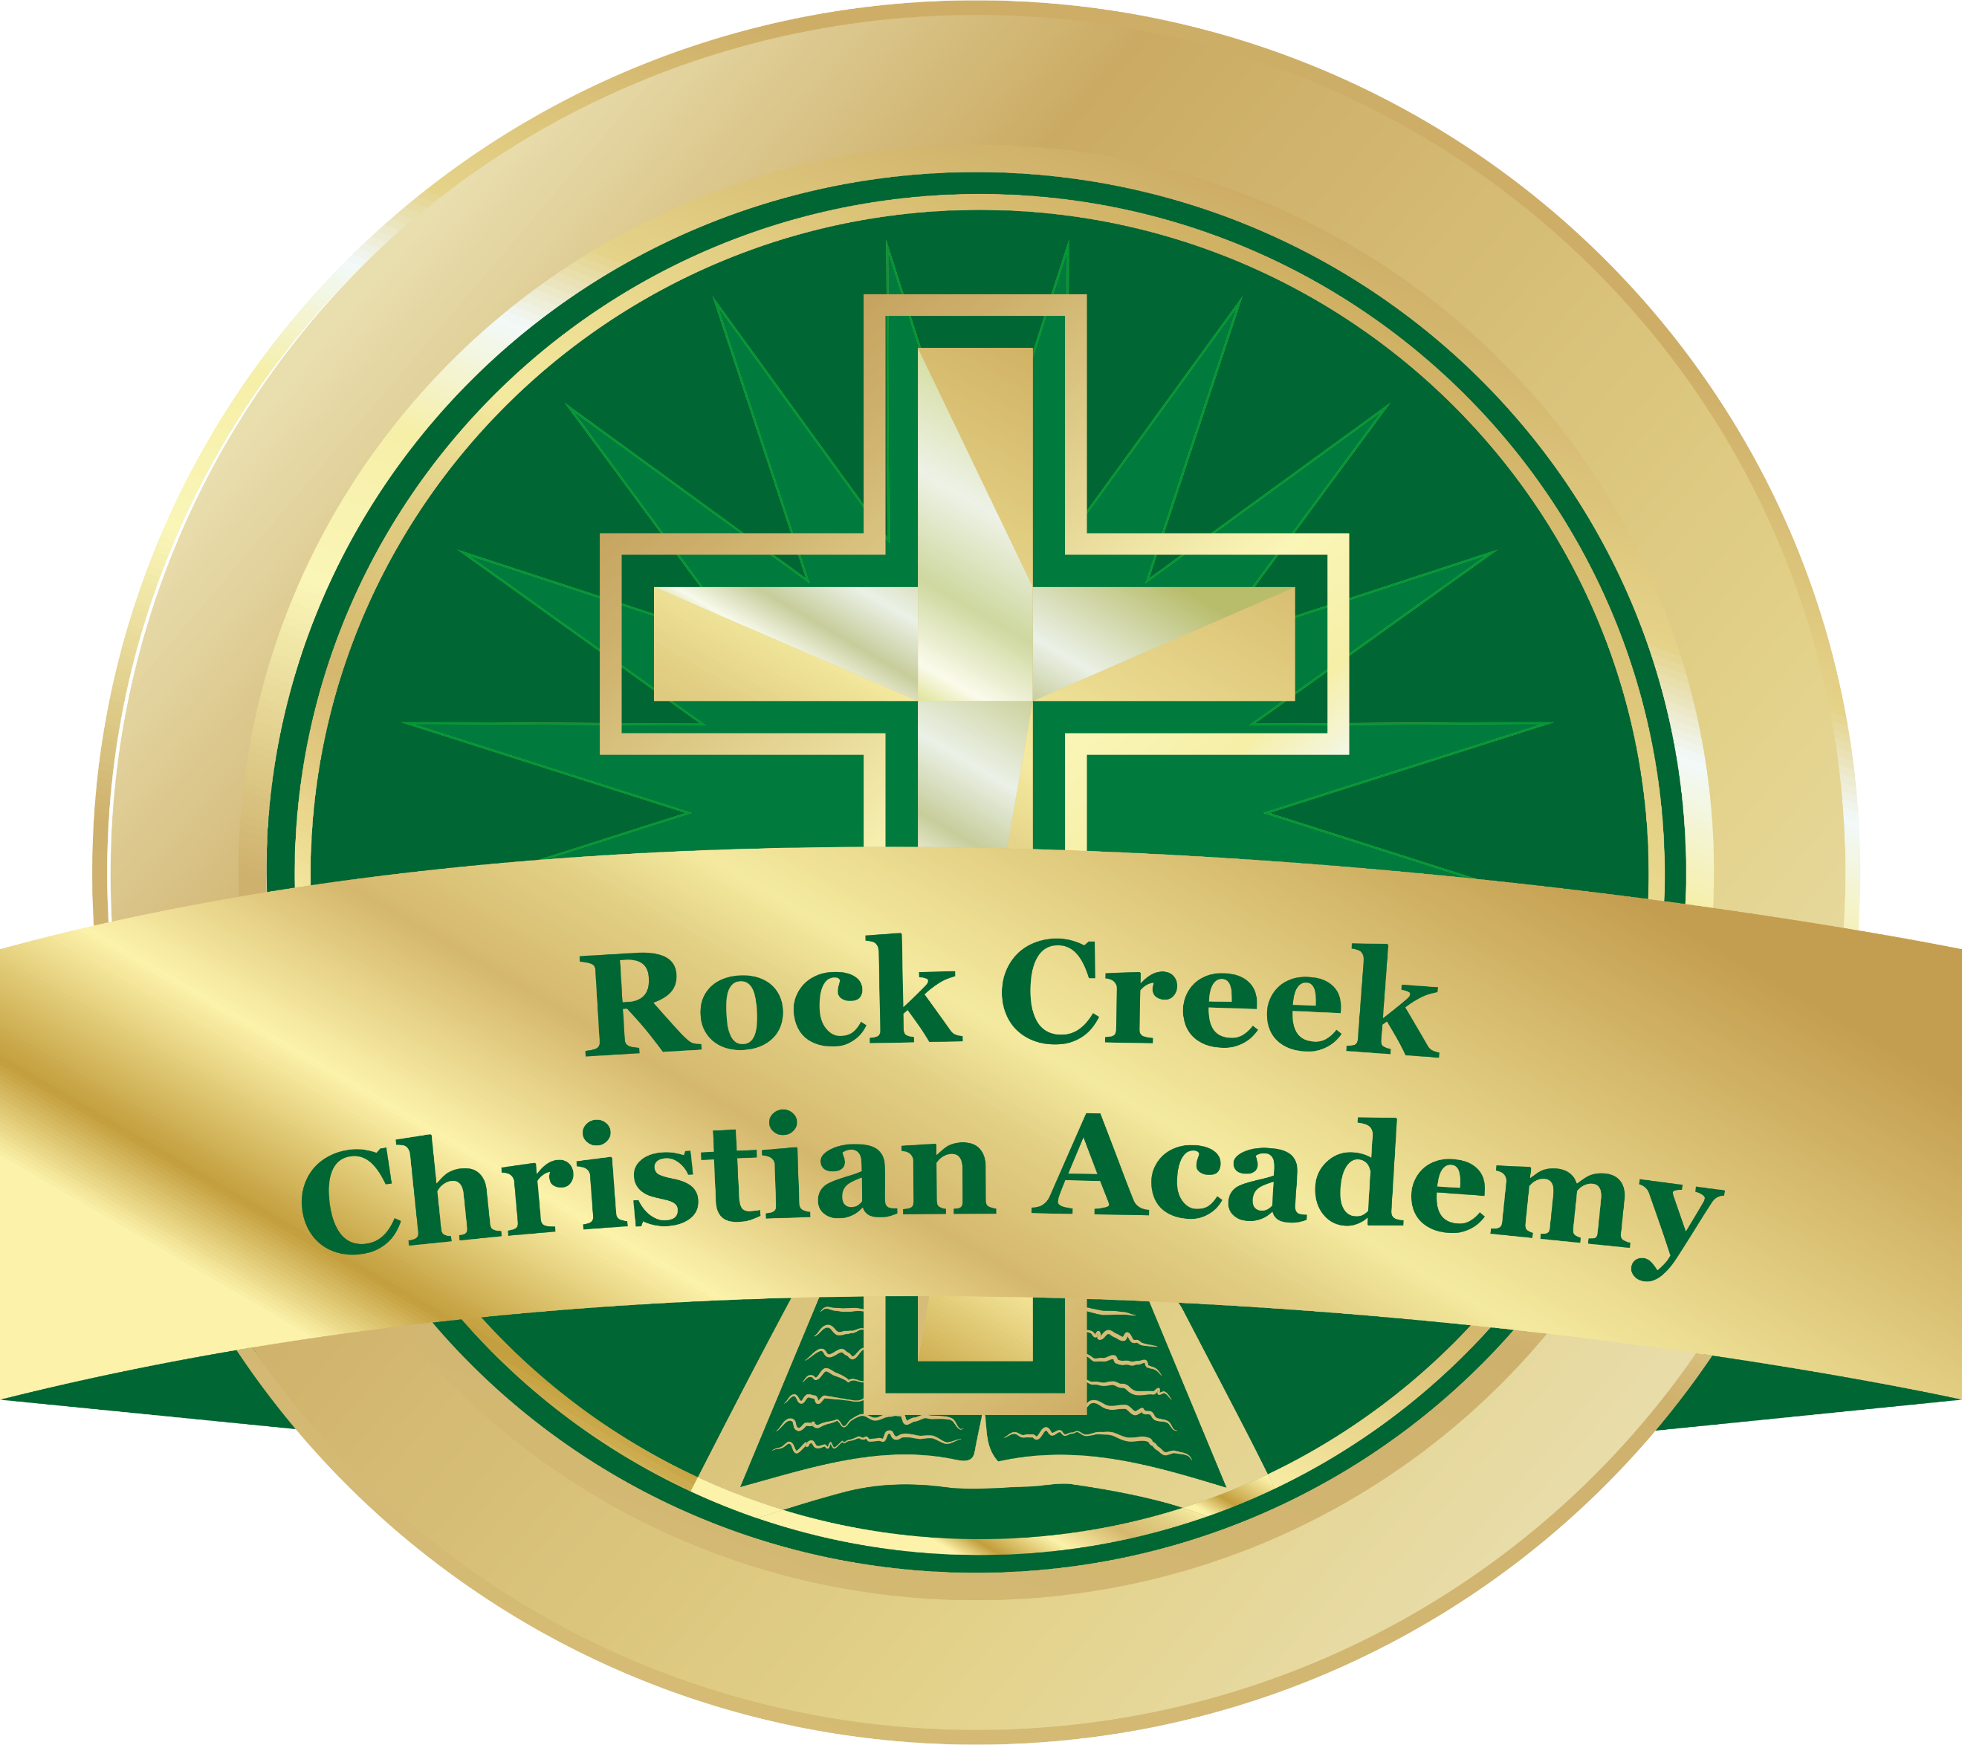

ROCK CREEK CHRISTIAN ACADEMY: 2019-2020
K4 School Supply List

- Pocket Folders (2)
- Large Glue Sticks - the purple type (2)
- Crayola Crayon (2 Boxes of 8)
- #2 Pencil (2 packs)
- Painting Smock or Large T-shirt
- Plastic Pencil Box
- Safety Scissors (Round tip)
- Play Dough (1 set)
- Backpack
- Uniform change of clothes (In a plastic bag with name)
- Sheet, small blanket and small pillow (with a storage container)
- Kleenex (4 boxes)
- Wipes-facial/hands (2 packs)
- Clorox wipes (4 containers)
- Hand soap (2 bottles)
- Hand sanitizer (2 bottles)
- Lysol spray (2 cans)

